Game Design Document

Fill up the Following document

1. Write the title of your project.

Deer Hunger

1. What is the goal of the game?

The player should –

1. Help the deer to eat Carrots as it is a Carrot lover.
2. Make the deer avoid eating meat as it is not a Carnivore.
3. Write a brief story of your game?

The deer is very hungry and as an Animal lover, it is your responsibility to feed the deer with its favorite food (Carrot).

1. Which are the playing characters of this game?

* Playing characters are the ones which respond to the user based on the input from the user
* Cars, monkeys, dinos, wizards etc, are the playing characters in the game.

|  |  |  |
| --- | --- | --- |
| Number | Character Name | What can this character do? |
| 1 | Deer | This character eats food based on the input from the user. |
|  |  |  |
|  |  |  |

1. Which are the Non Playing Characters of this game?

* Non Playing characters are the ones which don't have an action or a behaviour when the user interacts with the game.
* Hurdles, stones, bananas, coins, etc are non playing characters in the game.

|  |  |  |
| --- | --- | --- |
| Number | Character Name | What can this character do? |
| 1 | Carrot(Non – playing character) | These are randomly moving objects in the game. |
| 2 | Meat(Non – playing character) | Randomly moves in the game. |
| 3 |  |  |
| 4 |  |  |
| 5 |  |  |

Draw your imagination of this game. What does this game look like?

* Draw the game either on your computer or on paper,
* Add images of scenes of the game to show each of the playing and non-playing characters at least once.

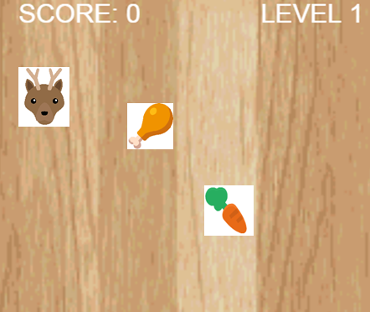

How do you plan to make your game engaging?

I plan to make my game engaging by listing out a amazing fact and by some attractive sound effects.